Grade 3/4 Supply List 2023-2024
Teacher: Mrs. Lori Kendall

- 12-32 page notebooks (no coils please)
- 1 Hilroy 80 Page notebook (no coil)
- 1” binder (no zippers please-these don’t fit in desks)
- 10 duotangs (each a different colour)
- 1 plain folder
- 1 package of 5 dividers
- 1 package of Post-it notes
- 4 red pens
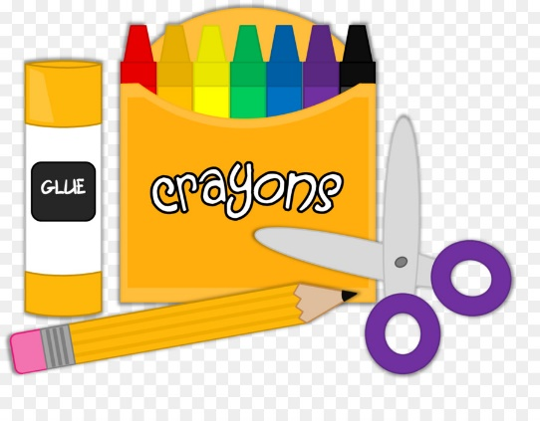
- 4 blue pens
- 50 pencils
- 1 pencil box or case
- 12 white erasers
- 1 ruler
- 1 set pencil crayons
- 1 set wax crayons
- 5 large glue sticks
- 1 bottle white glue
- 1 set markers
- 2 highlighters
- 1 pair scissors
- 1 calculator
- 2 black Sharpie markers
- 4 dry erase markers
- 1 set headphones
- 1 box assorted BandAids
- 2 boxes Kleenex (required)
- 1 empty 4” Lysol Wipes container
- Water bottle

Clearly label all supplies (individual pencils, crayons and markers) and place them in a Ziploc bag. I will keep the extra supplies in storage at the beginning of the school year.

