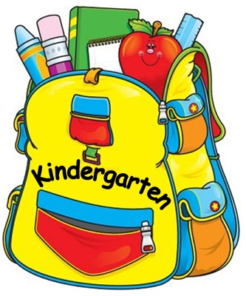
Ponteix Kindergarten Supplies List
- 10 pencils
- 2 white erasers
- 2 thin black dry erase markers
- 2 hard top pencil boxes
- 3 large glue sticks (preferably UHU brand - available at Staples - it is simply the kind that sticks the best in my experience).
- 1 small box wax crayons
- 1 small set of kids’ watercolors
- 1 paint shirt ( an old tshirt of a grown up works well - please label the tag of the shirt with your child’s name)
- 2 packages of Crayola Washable Markers (original colors)
- 1 binder (1 inch - no zippered binders please)
- 1 package of 5 tab dividers
- 1 school bag or backpack (large enough to fit library book, binder and lunch bag)
- 2 boxes of kleenex
- 1 container of disinfecting wipes
- 1 water bottle (this will come back and forth to school each day. No juice is allowed in class - only at lunch)
- 1 set of spare clothes (shirt, pants, underwear and socks) in a plastic bag labeled with name. This will be kept on hand in case of an accident or if your child gets wet or dirty at recess.
- 1 pair of indoor running shoes with velcro (no laces please unless your child is proficient at tying and untying their own shoes).

Please label ALL items and place small items in a large ziplock bag with your child’s name on it. Items not being used will be placed in a cabinet to be available as needed, with any unused supplies sent home at the end of the school year.

*Note* - students will have snack time at 10:40 each morning. Students are responsible for bringing their own snack so please send a nutritious option for your child to eat. *No peanuts please due to allergies in our building*

