Grade 5 / 6 Supply List 2023 – 2024
- 6 notebooks (40 pages)
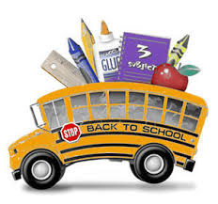
- 8 duotangs
- 1 package loose-leaf (at least 100 sheets)
- 1 – 1” binder (not zipped)
- 1 package dividers
- 2 twin-pocket folders
- 2 red pens
- 2 blue pens
- 50 HB pencils
- 1 set pencil crayons
- 1 set markers (12-24 Crayola or coloured Sharpies)
- 3 black Sharpie markers (2 thin and 1 thick)
- 3 high-lighters
- 6 dry-erase markers
- 1 white board eraser
- 6 white erasers
- 1 pencil case big enough to hold all markers, pencil crayons
1 small pencil case to hold pencil, eraser, whiteboard marker & eraser)
- 4 large glue sticks
- 1 bottle of white glue
- 1 dictionary
- 1 pair scissors
- 1 package Post-It notes
- 1 calculator
- 1 – 30 cm ruler
- 1 protractor
- 1 water bottle
- 1 pair indoor running shoes (required for physical education class)
locker essentials:
- 1 box tissues
- deodorant or anti-perspirant
- 1 pair headphones
- bandaids
- tampons / pads if applicable
- emergency non-perishable snack supply for “oops I forgot days” ie. box of granola bars / fruit snacks / apple sauces ...)
- 2 large Ziploc plastic bags for storage

Please clearly label all items

