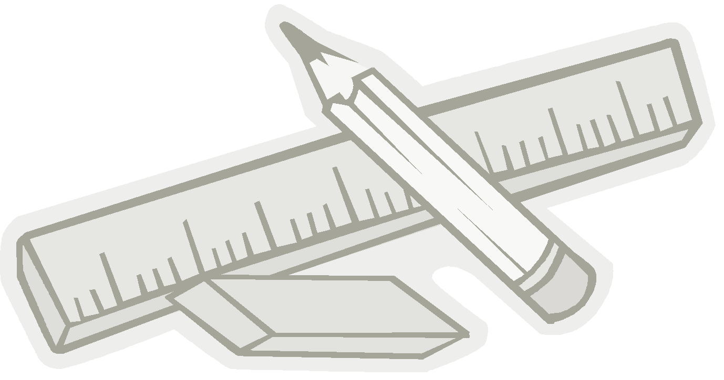
Gull Lake School
Kindergarten – Mrs. Judge
School Supply List 2020-2021

Label the following:
3 duotangs (different colours)
2 Hilroy small exercise books (plain, no lines)
1 pair scissors (metal blades)
1 one inch binder
1 backpack
1 lunch kit
1 water bottle (optional)
1 pair of running shoes to be left at school (velcro, no black soles)
1 pair of extra clothes (shirt, pants, socks, underwear) in a labeled ziploc bag
1 hardtop pencil cases
1 set of headphones (no ear buds)
1 paint shirt (an old T-shirt of mom or dad works!)
10 HB pencils, sharpened
3 large glue sticks
1 box of 24 crayons
1 box of broad tip washable crayola markers (original colours only - 8)
2 white erasers
1 bottle of white glue
Hand sanitizer

No need to label the following:
1 box of large ziploc bags
1 box of kleenex
1 container of playdoh
1 4x6 family photo to be kept at school for the year

