Cougar Strong Award of Excellence
In Memory of Angela Boorah
This school year marks the third year of the Cougar Strong Award of Excellence, which is based on the criteria of student behaviour, school involvement, charity/fundraising work and academic excellence. This is an extra special award here at Central School as it is in memory of a very special teacher, Mrs. Angela Boorah.
Mrs. Boorah began teaching at Central School in 2007, where she taught grade 4 as well as served as vice-principal in 2014. Following that school year Mrs. Boorah went on maternity leave and then shortly later was diagnosed with cancer. After a long and arduous battle with cancer, Mrs. Boorah passed away on August 13th, 2017.
There are a number of noteworthy things that Mrs. Boorah is remembered for. She is remembered as not only a colleague, but as a friend to everyone on staff. She is remembered for always putting her students’ learning first, and seeking to create meaningful relationships with everyone in her class. She is remembered for being a hard worker, a team player, and a problem solver that was solution focused. She is remembered as a positive individual, who would never spread negativity or speak a bad word about others. For these reasons, as well as many others, Mrs. Boorah will forever be missed.

The 2019-2020 recipient of the Cougar Strong Award of Excellence is... Vidhee Teekoory!
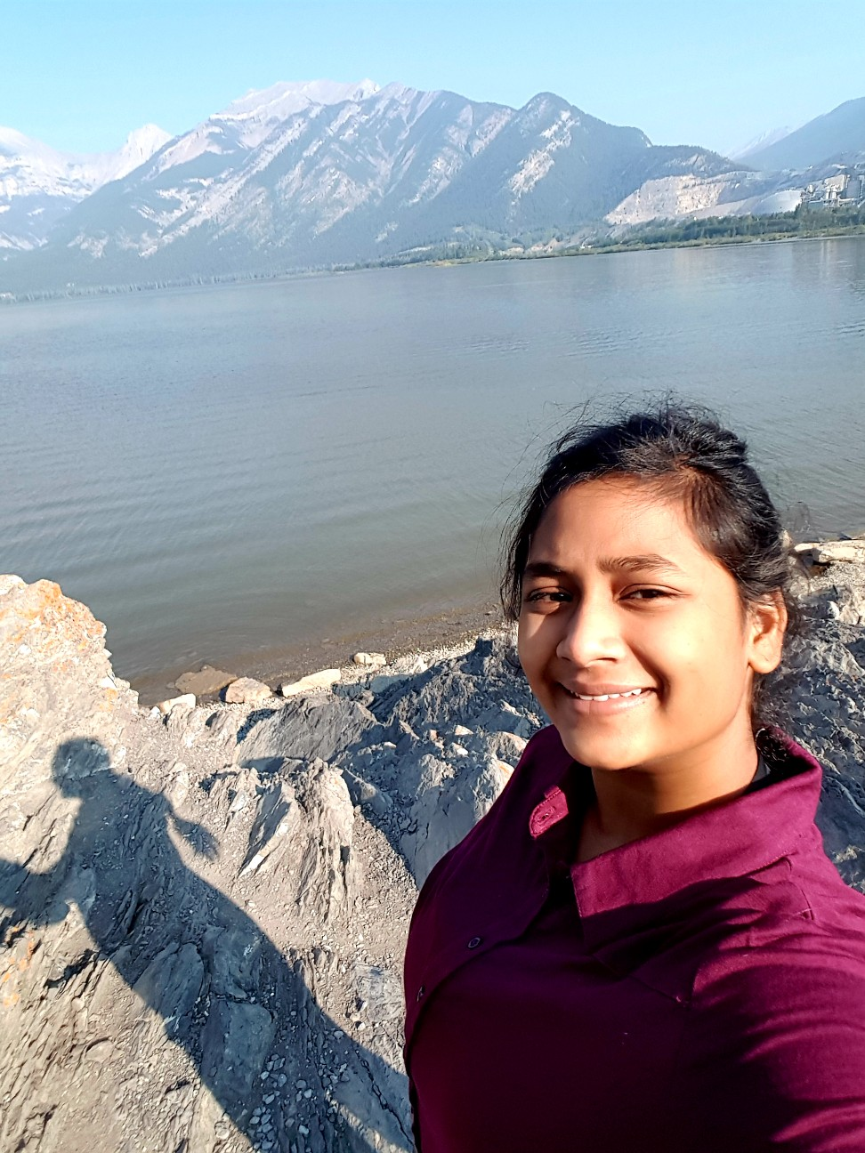

Vidhee is a hardworking, determined student who is passionate about everything she does. All year long, Vidhee has been committed to learning. She is not afraid to ask questions and challenge herself to further her understanding. She stayed organized throughout the year allowing her to meet every assignment deadline. Not only is Vidhee an outstanding student academically, but she is an active participant in extracurricular activities at Central School. She participated in volleyball, basketball, yearbook, and Spirit Club. Vidhee always had a positive attitude no matter what task or activity she was facing. When partaking in fundraising activities, Vidhee went above and beyond to raise funds for the basketball jerseys. Vidhee is a perfect example of what it means to be Cougar Strong. She will be greatly missed at Central School!

