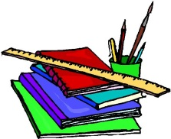
Grade Seven Supply List 2017-2018
Ms. Leanne Drullette
- 2 packages of index dividers with insertable tabs
- Hilroy lined looseleaf paper – 200 sheets
- 2 Bic pen – medium red
- 2 Bic pen – medium blue
- 2 Bic highlighters (assorted colours)
- 30 sharpened pencils
- Coloured pencils (sharpened)
- 6 white erasers
- 10 duotangs
- 2 Hilroy coil note book – 80 pages
- 2 – 2” binders (one for ELA, one for math)
- 10 pack of Crayola markers
- Scissors
- 4 glue sticks
- 30 cm clear plastic ruler
- Pencil sharpener with container
- Pencil case
- reinforcements
- 10 piece geometry set
- Calculator (preferably one with π (pi) on it)
- 2 Boxes of facial tissue
- Headphones (due to the occasional occurrence of head lice)
- Oxford Canadian Dictionary of Current English
- Indoor running shoes for Gym (non-marking)
- Badminton googles in the spring

