Box 1809
Swift Current, SK S9H 4J8
Email: aevjen67@chinooksd.ca
Fax: (306) 778-9239

CITY SCHOOLS TRANSPORTATION PROCESS

Welcome to e-Link
We have a browser-based program that provides you with access to your bus route information online. This software system allows you to locate your bus stop, see the time of pick up and drop off, the bus number and symbol. Please be aware that this option is only available to routes within the city. If you use a rural bus, your driver will contact you for pick up and drop off times in August as in previous years.

To access this information, you will require your child’s Student I.D. number, this number can be found in your MSS account and is located as circled in the sample below. Please keep a record of this number as it will be used to access your bussing information going forward. Your password will always be the word “password’ and this will not change. Please use the following link(s) to access all your bussing information.

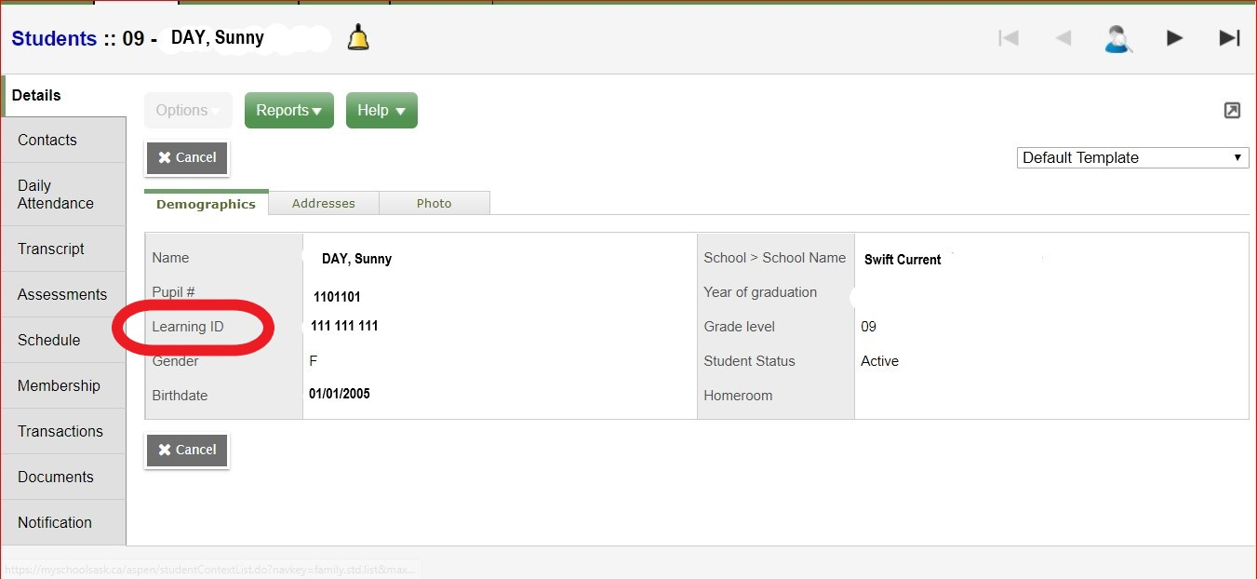

STEP 1:
Versatrans e-Link
or type in: https://versatransweb04.tylertech.com/Chinook/elinkrp/Welcome.aspx

This link can also be found on the Chinook School Division Website. Click on the second bullet under the Bus Information tab.

STEP 2:
Once you are at the home page please enter your Student ID number as the User Name and the word “password” for the Password.
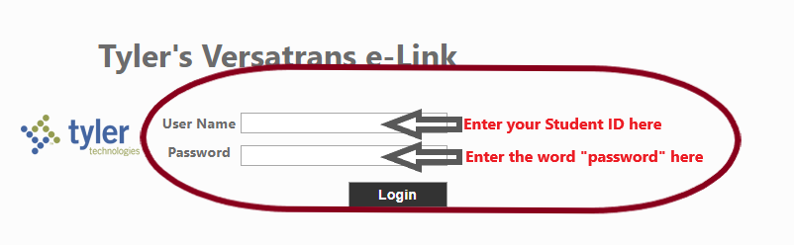
STEP 3:
It will take you to this home screen and you will double click on the “Work with Students” link.
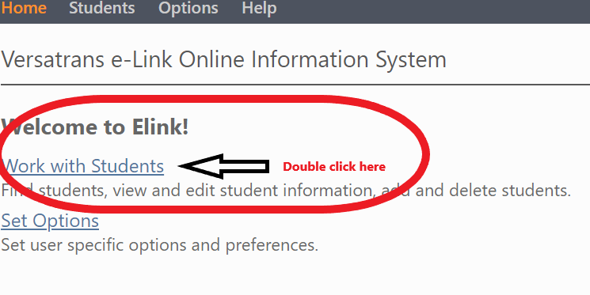
STEP 4:
Double click on the student name and the bus details will be available to view like the sample below. If you are seeing an error or not finding your student, please email aevjen67@chinooksd.ca
